**Filename Plan**

All sound files will be in the Vorbis (.ogg) format. All audio filenames will be created so that the location/position/type of the sound is intuitive.

e.g. Location / Description

Location - upside down world or normal world (usw / nw)

Description – impact sounds (usw-is-slap2, nw-is-crash3), background music (usw-bg2, nw-bg3)

The audio will be tailored for use in different levels or zones. The list below is a preliminary sound plan and will be further developed as the game design progresses.

1. **Impact sounds** (is)

hits, thuds, slaps, crashes, breaking windows, combat/fight sounds

1. **Background music** (bg)

variation in levels, upside down world vs normal world

1. **Text submission / Decision sounds** (ts)

typing, submission, output of text on screen from NPCs

1. **Health-related sounds** (hs)

changes in health, running out of health, full health

**Required Sound Files**

Each zone has a number of different game interactions. Each interaction will be accompanied by a relevant sound. The zones also have a specific background sound, depending on whether the player is within the normal or alternate world.

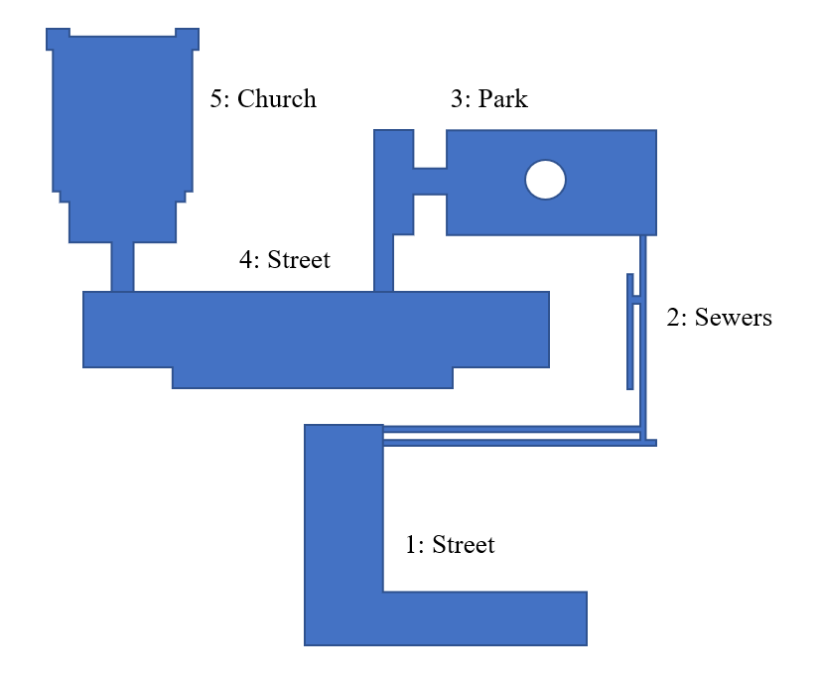

**Zone Background Sounds**

|  |  |
| --- | --- |
| *Location: filename*  *Normal World (nw)…*   1. Street: nw-bg1 2. Sewer: nw-bg2 3. Park: nw-bg3 4. Street: nw-bg4 5. Church: nw-bg5 | *Alternate World (usw)…*  1. Street: usw-bg1  2. Sewer: usw-bg2  3. Park: usw-bg3  4. Street: usw-bg4  5. Church: nw-bg5 |

**Zone 1 – Interaction Sounds**

1. Zone Start Sound
2. Puzzles
   1. Puzzle Completed
   2. Puzzle Fail
3. Zone End/Leave Sound

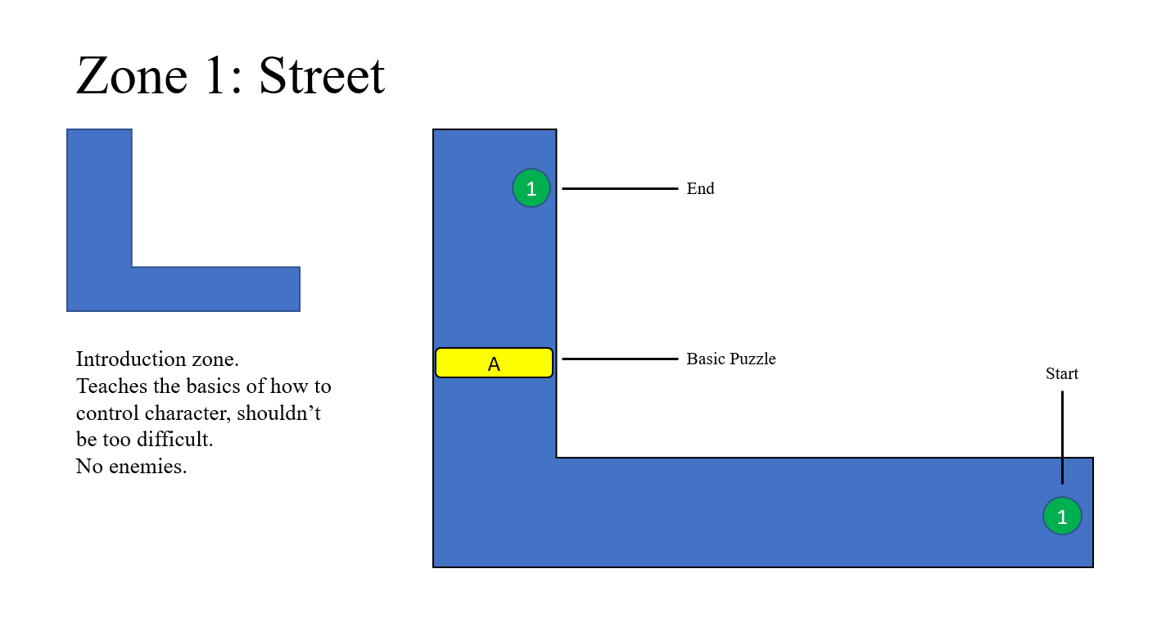

**Zones 2 - 4 – Interaction Sounds**

1. Zone Start Sound
2. Puzzles
   1. Puzzle Completed
   2. Puzzle Fail
3. Zone End/Leave Sound
4. Health Boost
5. Sewer Enemy
   1. Combat Sound Successful
   2. Combat Sound Fail

1. Health Reduction (after Combat Fail)

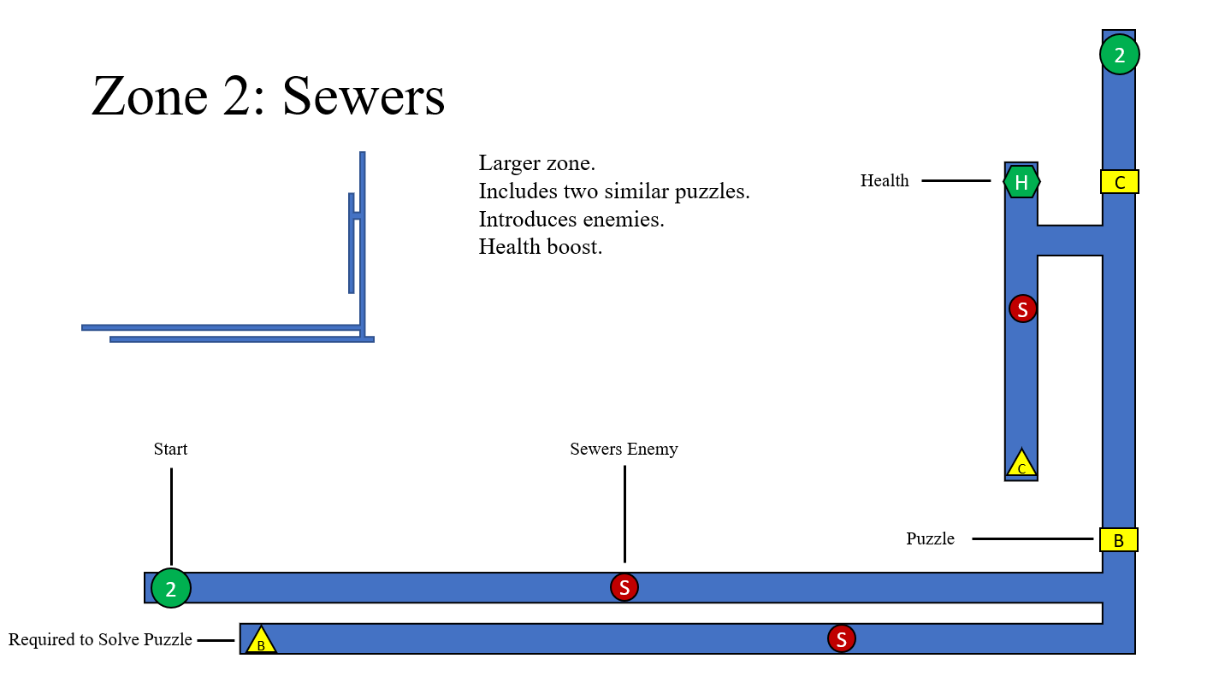

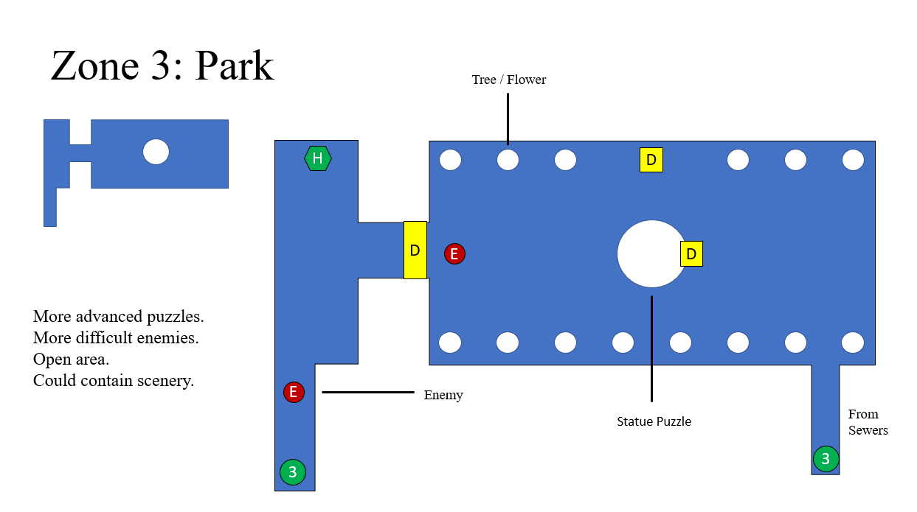

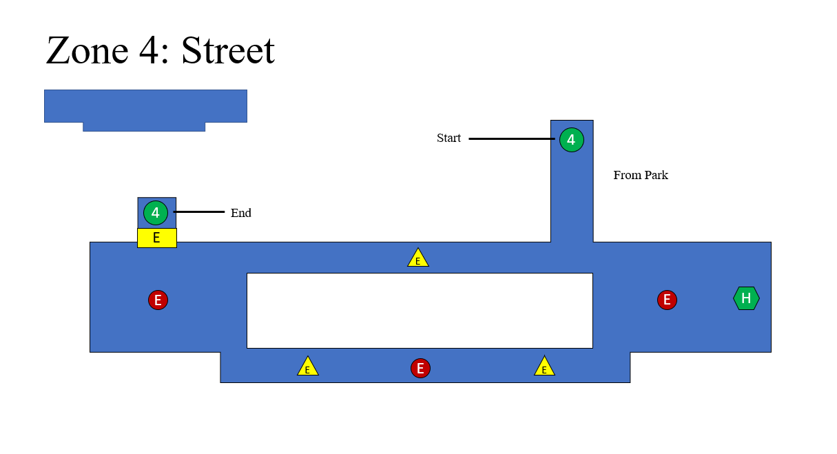

**Zone 5 – Interaction Sounds**

1. Zone Start Sound
2. Puzzle
   1. Puzzle Completed
   2. Puzzle Fail
3. Zone End/Leave Sound
4. Health Boost
5. Health Reduction (after Combat Fail)
6. Final Boss
   1. Combat Sound Successful
   2. Combat Sound Fail
   3. Game Completed

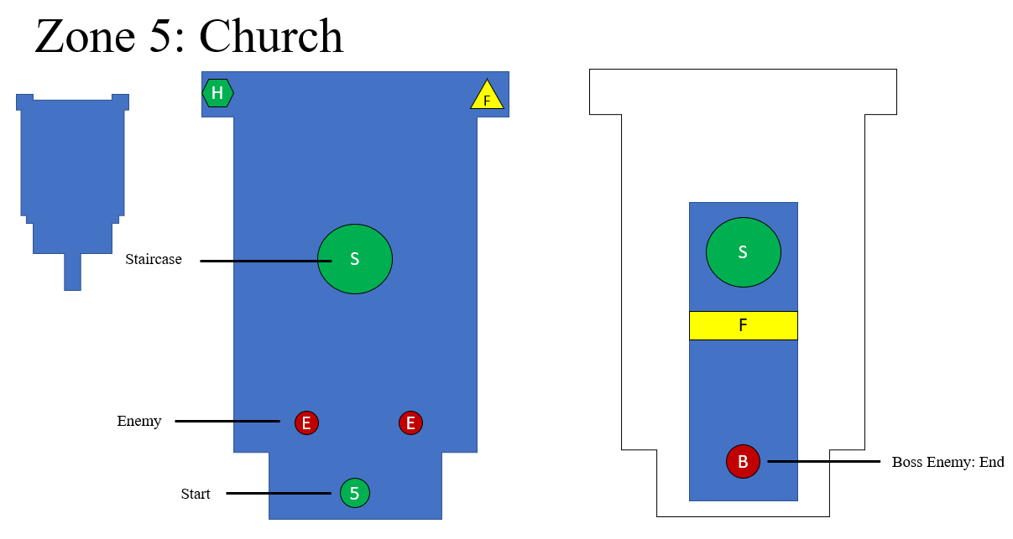

**Credits**

Map Designs by Luke Davies

**Global Sounds**

As the game sounds have developed it became clear that there would be a mix of zonal background sounds that depicted whether the player was in the ‘normal world (nw)’ or the ‘upside down world (usw) / alternate world’. The zone start sound would be the relevant background sound for that zone.

All additional sounds have been classified as global sounds.

To track the completion of the sounds I have used an Excel sheet to monitor and signify the filenames. A list of the actual global and zonal sound types is shown below. Some of these sound types have several sound options to allow for variety within the game.

